

ACADEMIC BOARD POLICY: ACADEMIC DISHONESTY AND PLAGIARISM
COMPLIANCE STATEMENT
INDIVIDUAL / COLLABORATIVE WORK

I/We certify that:
(1) I/We have read and understood the University of Sydney Academic Board Policy: Academic Dishonesty and Plagiarism;
(2) I/We understand that failure to comply with the Academic Board Policy: Academic Dishonesty and Plagiarism can lead to the University commencing proceedings against me/us for potential student misconduct under Chapter 8 of the University of Sydney By-Law 1999 (as amended);
(3) This Work is substantially my/our own, and to the extent that any part of this Work is not my/our own I/we have indicated that it is not my/our own by Acknowledging the Source of that part or those parts of the Work;
(4) No part of this Work has been previously submitted for summative assessment, whether in this Unit of Study or another Unit of Study (unless the Examiner has given specific approval for this to occur);
(5) I/We accept that the Work submitted with this Compliance Statement is the version of the Work that will be assessed.

Complete all fields in the following table for yourself (in the case of individual work), OR for ALL members of your group (in the case of collaborative work).
Typewritten name(s) in the signature column will be accepted as signature(s) for electronic submissions only.
Name | Signature | SID | Date
James Ferris | 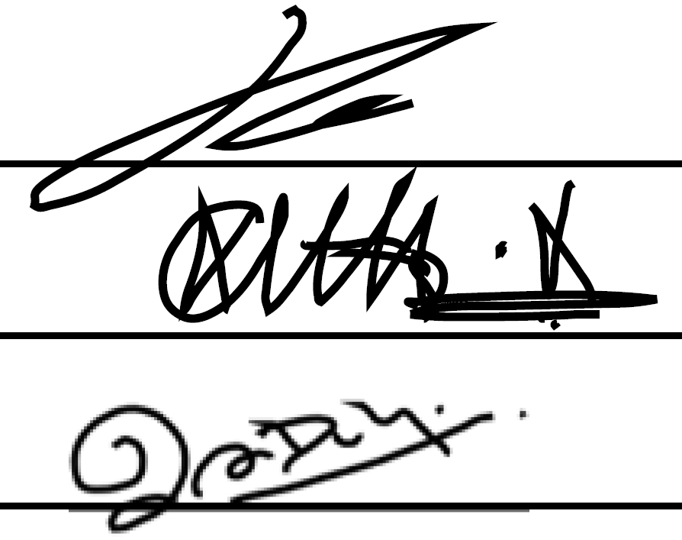 | 311220045 | 19/6/15
Kausthub Krishnamurthy |  | 312086040 | 19/6/15
Sachith Gunawardhana |  | 440623630 | 19/6/15

